
Grants Programme Officer

WELCOME

Hi there,
Thank you for exploring this role.
We’ve been building our approach to the Living Well with Psychosis programme for 3 years now and we’re excited to be expanding the team. This role will be joining our two existing Grants Programmes Officers, focusing on the Living Well with Psychosis programme.
We’re looking forward to receiving your application.
Venetia Boon
Programme Lead, Living Well with Psychosis

About Maudsley Charity

Maudsley Charity is a grant-making charity that advances and accelerates positive change in mental health care in south London.
We fund and support key clinical, academic and community partners so that everyone who experiences mental illness, without exception, can access the care that’s right for them.
While our roots are embedded firmly in our local community in south London, we aim to also seed positive change in mental health care elsewhere in the UK, by sharing and amplifying the knowledge and evidence that is generated through the work that we fund.

Why we’re here
Mental illness can have a profound impact on a person’s life – affecting their relationships, education, career, and physical health.
Our approach is led by clear and undeniable evidence that not everyone who experiences mental illness receives the care they need to live as well as possible.
In south London, there are clear differences in the risk of mental illness, and the experience and outcomes from care. The impact of social deprivation and racism are especially stark.

How we work
Our approach is grounded in evidence, experience and equity:
Evidence: We identify and financially back the most promising solutions that draw on and generate learning and evidence.
Experience: Mental health care is more effective when it is informed by relevant expertise and lived experience.
Equity: We focus our funding on those most failed by services and society, driving improvements that benefit everyone.

The change we want to see
- Greater equity in care and support
- High-quality, evidence-based treatment available to all
- Care shaped by diverse expertise and lived experience
- Earlier intervention
- More people living well with mental illness
View our full strategy

Is this role right for me?
- We’re looking for someone who is keen to find out more about grant-making and management.
- This role would be right for you if you’re keen to learn about the best ways of thinking about inclusivity when distributing money and support.
- We’re looking for someone who can point to the change they have made in previous teams and share what they learnt from that.

What our existing Grants Programme Officers say:
If you'd had this role a year ago, you could have led on administrative and project management support for programmes, assisting Programme Leads in planning effectively so opportunities for collaboration and sharing of learning across programmes can be developed.
You could have also been involved with developing and evolving policies, procedures and tools to support the team's commitment to our inclusive grant making principles through collaborating with teams and colleagues across the organisation.
You could also have had the chance to:
- Be involved in and shape assessment processes
- Contribute to deliberation discussions
- Support with the planning and facilitation of events
- Worked on external communications
- Worked closely with learning and support partners
- Lead a small grants programme - shaping criteria, recruiting a decision making panel and ensuring the process is inclusive

What’s in the contract?

What’s the job title?​ | Grants Programme Officer
What will I earn?​ | £35,000
Where would I work?​ | Charity office and homeworking - hybrid working
Who do I report to?​ | Programme Lead (Living Well with Psychosis)
Who reports to me?​ | No direct reports
What are the hours?​ | 37.5
Is there flexibility?​ | Yes. Flexible working requests are welcome, however, the role will need to cover a minimum of 4 to 5 days.
When can I start?​ | From September 2026

What’s in the job description?
This isn’t an exhaustive list of responsibilities, but the key activities the role will work on.
We know that the role and the person in it will evolve and develop, and with whatever support you need, you’ll be part of making that happen.

Role purpose
The role will be responsible for managing grant application processes and a grant portfolio with guidance from a Programme Lead. The role will be part of our Programmes team and will work with NHS and King’s College London colleagues as well as local community and voluntary sector organisations.

The role will also provide project management and administration support to our team of Programme Leads on specific areas of work, and will take part in our learning and development activities. The role will act as first point of contact with grants queries.

Accountabilities

Grant management
- Communicate with applicants on stages of the process and requesting information. Add data to our grants management system. Review information for due diligence checks (with training, guidance and support). Take minutes for decision making meetings.
- Take part in assessment exercises by reviewing bids and budgets (with support and training). Score those bids and contribute to discussions on what funding is awarded.
- Arrange check in meetings with grant holders, review progress reports (with training and sup-port), request follow up document as necessary. Work closely with and to the Programme Lead.
- Support Programme Leads by thinking through timelines, providing updates on activities and delivering administrative tasks.
- Respond to queries received in our Grants inbox in a timely and efficient way. Support people when they are struggling to update our grants management system and help them to do what they need to do.

Impact development
- Gather knowledge and learning by requesting data, reports or meetings from grant holders as needed for communications and monitoring purposes.
- Support the delivery of events by planning and managing the guest list, the catering requirements and any accessibility needs. Send any follow-on communication to attendees.

Systems and processes
- Follow our grant management processes and work with colleagues to contribute ideas to their ongoing improvement
- Update the grant management system with relevant information (with training and support). Add relevant data, reports and emails to the system in line with our grants process.
Collaborate across the Charity
- Communicate with grant holders to gather case studies, data or reports. Share with our communications team.

Benefits
Maudsley Charity team have embraced hybrid working. We all come together at least monthly for team meetings, with other check-ins and meetings held virtually or in person. On average, team members spend 50% of their working week located in our multi-award-winning home, the Ortus building.
Situated a few minutes’ walk from Denmark Hill station, South London, the Ortus building is close to the Maudsley Hospital and King’s College London’s Institute of Psychiatry, Psychology and Neuroscience, both centres of world class excellence in the field of mental health and wellbeing. The building is open to the public, hosting exhibitions, events and conferences, as well as being available for room hire.
We offer a friendly, values-led working culture, with the following benefits for our staff. ​
- Hybrid working, 2-3 days spent with the team in our building each week and 2-3 days at home/offsite working for full time staff. It’s important to us to come together often, whether that’s to collaborate, be social, or get a change of scenery. ​
- 25 days annual leave, with a further one day after three years’ service and a further one day after five years’ service. Plus, additional non-working office closure days over the Christmas period.​
- Pension scheme with up to 6% employer contribution, subject to a minimum 3% employee contribution. ​
- A cycle-to-work scheme.​
- Enhanced occupational maternity, paternity, adoption, and shared parental leave pay (after qualifying length of service). ​
- Interest-free season ticket loans (after probation).​
- Group Life Assurance - providing employees with a tax-free lump sum of four times your basic salary in the event of your death, for your dependants (after qualifying length of service). ​
- Group Income Protection Scheme - protecting you if you are sick long-term, by paying 75% of your basic salary with a deferred period of 13 weeks (after qualifying length of service). ​
- Comprehensive package of online and face-to-face training for staff.​
- Employee Assistance Programme (EAP) – supporting staff to stay well. ​
- 20% discount on all food and drinks at the Ortus café.​
- Working in an inclusive environment where diversity, equity and inclusion is completely embedded. We ensure our pace, and our ways of working delivers our commitment, as well as specific opportunities such as sitting on our DEI and Ways of Working groups.
- Working with a diverse team, Board of Trustees, and colleagues across our partners.​

OUR ORGANISATION
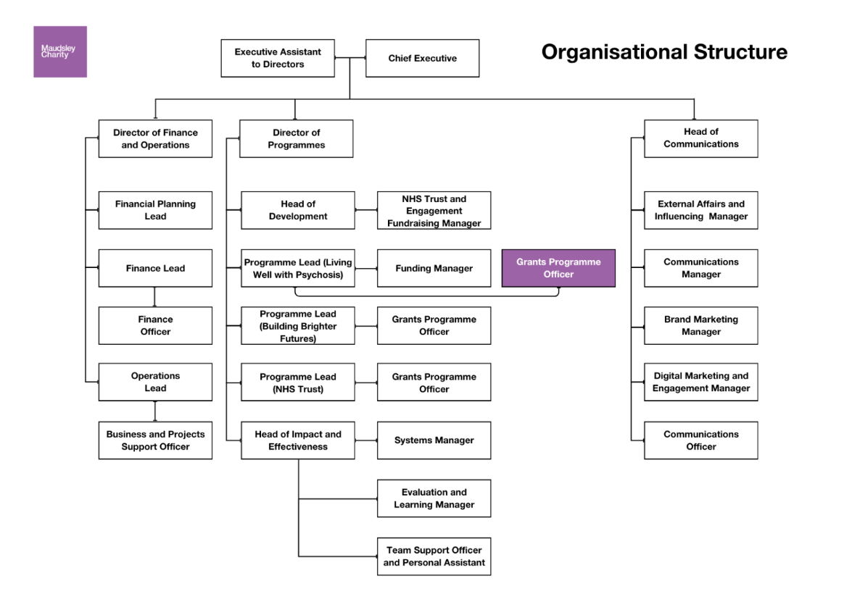

HOW TO APPLY AND THE APPLICATION PROCESS
The Charity is serious about building a diverse team. We’ve increased the time and budget we spend on recruitment to ensure we place more adverts in more places to reach more people, and we’ve looked at each stage of the recruitment process to remove biases. We encourage applications from global majority backgrounds or people who self identify as being from a working-class community.

Before you apply
Join our ‘Ask Us Anything’ webinar on Monday 13th July at 12.30. Use the following link to register for the webinar:
Webinar Registration - Zoom
You won’t see or hear other candidates, and you’ll be anonymous, so we don’t undermine our blind recruitment process. You really can ask us anything – about the role, the process, our work, culture, team.

Your application
We are committed to offering interviews to candidates who meet the role requirements and have lived experience of mental illness or a disability.
Once you have expressed your interest to Charity People, you will be sent a set of qualifying questions to answer – we do not accept cover letters as part of the application process. Your identity will be completely anonymous to the panel who will score your answers independently. We will only see your CV if you are shortlisted.
Submit your answers in written format or in a voice memo. We’ll type up any recordings to maintain anonymity.

The interview
We’ll ask you if you have any needs for the interview and put any reasonable adjustments in place.
We’ll pay for your travel expenses within the UK if you need us to.
We’ll give you the interview questions before each round. We want you to perform to your best, and we know that this can help some to do that.
The interview will be face-to-face at our offices in Denmark Hill, southeast London.
We’ll ask values and competency-based questions in the interview. This is to ensure we focus decisions on your potential performance in the role.
We’ll only share scores and discuss candidates as a panel when all candidates have been seen; to remove any influence panel members might have over each other.

The Interview Panel
Venetia Boon – Programme Lead - Living Well with Psychosis
Mary Sadid – Funding Manager
Madeleine Trubee – Grants Programme Officer
We hope you will consider making an application. If you have questions about the appointment and would find it helpful to have an informal conversation, please contact Charity People and we will be happy to arrange a call.
We would also be grateful if you would complete the Equality and Diversity monitoring form on the online application process. This form is for monitoring purposes only and is not treated as part of your application.
Closing date: Tuesday 22nd July at 9am
Interviews (in person): 6th August or 10th August
Maudsley Charity is an equal opportunities employer, and makes no discrimination on the grounds of age, disability, gender reassignment, marriage and civil partnership, pregnancy and maternity, race, religion or belief and sex. Specifically, we will also oppose unfair discrimination of those with mental health issues.

Maudsley Charity Diversity, Equality and Inclusion Commitments
The Charity will:
- Highlight that discrimination or unequal treatment on the grounds of mental health or other protected characteristics can undermine mental wellbeing and work to address inequalities and discrimination.
- Create a zero-tolerance working environment in respect of discrimination, harassment, bullying or victimisation, collectively called unacceptable behaviour so that everyone can work without fear of the unacceptable behaviours. A Dignity & Respect policy is in place to support this and address issues.
- Implement a Recruitment Policy to ensure that all appointments are made in accordance with the objectives of this policy.
- Monitor recruitment, service provision and grant-giving and take positive action based upon such information.
- Provide training and development opportunities that enable equality of opportunity, and which promote an awareness of diversity and inclusion.
- Ensure that Maudsley Charity premises and resources are made as accessible as possible to staff, users and all those who visit us, under the Disability Discrimination Act.
- Make reasonable adjustments for disabled people wherever possible.

